FINANCIAL TRANSACTION AND LOANS DASHBOARD

Submitted by: Niveditha Aanand
Roll No: E25FA059
Department: B.Com FinTech with AI 2nd Year
1. Introduction
For this project, I created a Financial Transaction and Loans Dashboard using Microsoft Power BI. The dashboard presents financial information related to transactions, customers, accounts and loans in a visual format. It helps users understand transaction activity, compare different account categories and observe the status of loans.
The dashboard combines KPI cards, charts, a summary table and interactive filters. These features make it easier to understand large amounts of financial data and identify important patterns without checking every record separately.
2. Objectives
The main objectives of this project are:
- To display the total transaction value, total customers, active accounts and active loans.
- To compare the number of accounts across different account types.
- To analyse monthly changes in transaction activity.
- To understand the distribution of loans by their status.
- To compare transaction counts across different transaction types.
- To use interactive filters to analyse selected years and categories.
- To display additional transaction information through a tooltip.
3. Dashboard Overview
The Financial Transaction and Loans Dashboard provides an overall view of financial activity through different visualisations. The top section contains four KPI cards showing total transaction value, total customers, active accounts and active loans.
The remaining sections contain a chart showing accounts by account type, a line chart showing monthly transactions, a pie chart representing loan status, a bar chart comparing transaction types and a table showing transaction counts and values.
The dashboard uses a dark background with blue-coloured charts to distinguish the different sections clearly. This layout helps users understand the overall financial position before examining individual categories in detail.
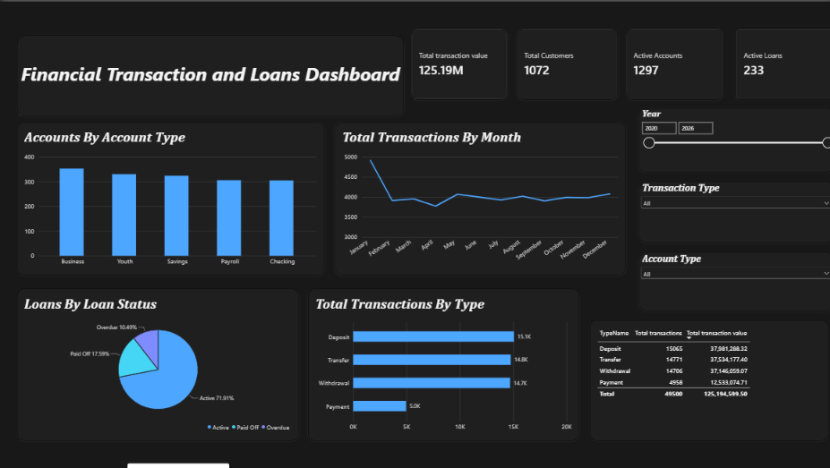
4. Key Performance Indicators (KPIs)
The dashboard contains four main KPIs.
4.1 Total Transaction Value
The total transaction value is approximately 125.19 million. This represents the overall monetary value of the transactions included in the dashboard.
4.2 Total Customers
The total customer count is 1,072. This KPI indicates the number of customers represented in the dashboard.
4.3 Active Accounts
The dashboard displays 1,297 active accounts. This measure provides an overview of the active accounts recorded in the dataset.
4.4 Active Loans
The total number of active loans is 233. This figure helps users understand the number of loans currently classified as active in the report.
Together, these KPIs provide a quick summary of the financial data and allow users to understand the overall scale of the transactions, customers, accounts and loans.
5. Accounts by Account Type
The column chart titled Accounts by Account Type compares five categories: Business, Youth, Savings, Payroll and Checking.
The Business category has the highest bar, with approximately 350 accounts. Youth and Savings accounts have slightly lower values, while Payroll and Checking accounts are close to 300 each.
This chart helps users understand how accounts are distributed across different categories. It also makes it easier to identify which account types are more common in the displayed data.
6. Total Transactions by Month
The line chart titled Total Transactions by Month displays transaction counts from January to December.
The chart begins at approximately 4,900 transactions in January. The total drops sharply to around 3,000 in February. After this decline, transaction activity fluctuates during the remaining months, with values mostly ranging between approximately 2,800 and 4,100.
A small recovery can be observed in May, followed by moderate changes throughout the rest of the year.
This chart helps identify months with higher and lower transaction activity. However, the chart alone does not explain why these changes occurred. Additional information would be needed to understand the reasons behind the monthly variations.
7. Loans by Loan Status
The pie chart titled Loans by Loan Status shows the distribution of loans across three categories: Active, Paid Off and Overdue.
The displayed distribution is:
- Active: 71.91%
- Paid Off: 17.59%
- Overdue: 10.49%
Active loans form the largest portion of the chart, indicating that most loans in the displayed data are classified as active.
Paid-off loans represent loans recorded as completed, while overdue loans account for a smaller portion of the total. The overdue category is important because it can help identify loans that may require additional monitoring or follow-up.
This chart provides a simple overview of the loan portfolio and its current status distribution.
8. Total Transactions by Type
The horizontal bar chart compares four transaction types: Deposit, Transfer, Withdrawal and Payment.
The approximate transaction counts shown are:
- Deposit: 15.1K
- Transfer: 14.8K
- Withdrawal: 14.7K
- Payment: 5.0K
Deposit transactions have the highest count, followed closely by transfers and withdrawals. Payment transactions have a considerably lower count than the other three categories.
This visualisation helps users understand which transaction types occur most frequently. It also makes comparisons easier because the transaction counts are displayed side by side.
9. Transaction Summary Table
The dashboard contains a table that presents transaction types alongside their total transaction counts and total transaction values.
The table includes the following categories:
- Deposit
- Transfer
- Withdrawal
- Payment
- Total
The table provides numerical details to support the transaction-type chart. While the bar chart focuses on comparing transaction counts visually, the table allows users to examine both the number of transactions and their monetary values.
The screenshot displays approximately 49,500 total transactions and a total transaction value of approximately 125.19 million.
This combination of charts and tabular information helps users understand both the frequency and financial value of different transaction categories.
10. Interactive Filters
The dashboard contains three interactive filter sections that allow users to examine selected parts of the data.
10.1 Year Filter
The year filter displays a range with 2020 and 2026 as the endpoints. It allows users to narrow the dashboard to a selected year or period.
10.2 Transaction Type Filter
This filter allows users to select a transaction category, such as Deposit, Transfer, Withdrawal or Payment. In the screenshot, the filter is set to All.
10.3 Account Type Filter
This filter allows users to focus on a particular account category, such as Business, Youth, Savings, Payroll or Checking. The screenshot shows All selected.
These filters make the dashboard interactive and allow users to compare financial information under different selections. When a filter is changed, the connected visuals can display the corresponding results.
11. Tooltip Analysis
The dashboard includes a separate tooltip view that provides additional details for a selected transaction type.
In the supplied screenshot, the tooltip displays the following information:
- First TypeName: Deposit
- Total transactions: 50K
- Total transaction value: 125.19M
The tooltip allows users to view additional information without adding more cards to the main dashboard. This helps keep the main report organised while providing extra details when required.
The displayed transaction count is reproduced as shown in the screenshot. Its formatting differs from the approximately 49,500 total transactions visible in the main table, so the exact measure or formatting would need to be checked in Power BI before reconciling the figures.
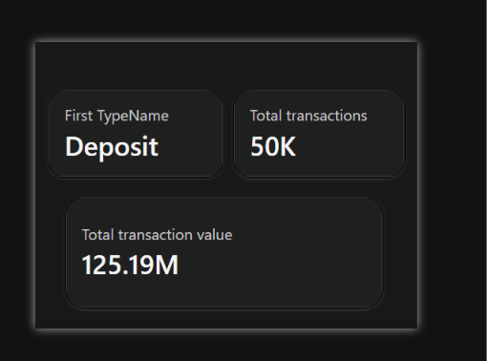12. Key Findings
The main findings from the dashboard are:
- The total transaction value is approximately 125.19 million.
- The dashboard displays 1,072 customers, 1,297 active accounts and 233 active loans.
- Business accounts have the highest count among the five account categories displayed.
- Transaction activity falls sharply between January and February and then fluctuates during the remaining months.
- Active loans represent approximately 71.91% of the loan-status distribution.
- Deposit transactions have the highest count among the four transaction types.
- Payment transactions have a significantly lower count than deposits, transfers and withdrawals.
- The transaction summary table provides both transaction counts and monetary values.
- The year, transaction-type and account-type filters allow users to explore selected portions of the data.
- The tooltip provides additional information about a selected transaction category.
13. Importance of the Dashboard
The dashboard is useful because it brings different types of financial information together in one place. Instead of reviewing separate tables and reports, users can examine transaction values, account categories, loan status and monthly activity on a single screen.
The KPI cards provide a quick overview of the main financial measures. The charts make it easier to compare categories and identify changes in transaction activity. The loan-status chart can help users monitor the distribution of active, paid-off and overdue loans.
The interactive filters further improve the usefulness of the dashboard by allowing users to focus on particular periods or categories. The tooltip provides extra information without making the main dashboard overcrowded.
However, the dashboard mainly highlights patterns and comparisons. Further examination of the underlying records may be necessary to understand the reasons for changes and support important financial decisions.
14. Conclusion
This project demonstrates how Microsoft Power BI can be used to present financial transaction and loan information through an interactive dashboard. The combination of KPI cards, charts, a summary table, filters and a tooltip makes the data easier to understand and analyse.
The dashboard shows that deposits are the most frequent transaction type, active loans form the largest loan-status category, and monthly transaction activity varies throughout the year. It also provides a clear summary of customers, accounts, loans and total transaction value.
Overall, the project helped demonstrate how data visualisation can support financial monitoring and analysis. The dashboard provides a useful starting point for identifying patterns, comparing financial categories and examining areas that may require further attention.
15. References
- Financial Transaction and Loans dataset used for the Power BI dashboard.
- Microsoft Power BI Desktop.
- Microsoft Power BI documentation.

